**REPRODUCTION IN PLANTS AND ANIMALS**

Definition of reproduction: Reproduction is the biological process by which new offspring/ individual organisms are produced from their parents. Reproduction is a characteristic of all living organisms; each individual organism exists as the result of reproduction. Reproduction is necessary for the maintenance of a particular species.

**Roles of reproduction**

* Reproduction majorly replaces members which die
* It is a means of increasing genetic varieties and therefore helping a species to adopt to changing environmental conditions
* Development of development of resistant stages in the lifecycle which are capable of withstanding adverse conditions e.g. spores in mosses.
* Reproduction involves the formation of spores, seeds and larvae which may be used to disperse the offspring and to reduce intra-specific competition among offspring.

**Types of reproduction**

There are two types of reproduction: sexual and asexual reproduction and these occur in both animals and plants.

Definition of asexual reproduction: This is the production of offspring from one parent without the fusion of the nuclei of the male and female gametes.

Definition of sexual reproduction: This is the production of offspring from the fusion of the nuclei of haploid male and female gametes to form a diploid zygote

The fusion of nuclei of male and female gametes is referred to as fertilization. It produces offspring that are genetically different.

**COMPARISON BETWEEN SEXUAL REPRODUCTION AND ASEXUAL REPRODUCTION**

Similarities

* In both mitosis is involved
* Both produce new individuals/ offspring
* Both involve transmission of genetic information from parents to their offspring Differences

|  |  |  |
| --- | --- | --- |
| Sexual |  | Asexual |
|  | Gamete formation involved  Fertilization occurs to form a diploid zygote Population increases slow due to few offspring produced at a time Offspring mature slowly  Involves one or two parents  Offspring show genetic variability | * No gamete formation * No fertilization * There is rapid population increase due to many offspring produced at a time * Offspring mature rapidly * Involves only one parent * Offspring are identical to each other and to the parent |

## **ASEXUAL REPRODUCTION.**

There are five types of asexual reproduction:

1. Fission
2. Sporulation (sporeformation)
3. Budding
4. Fragmentation
5. Vegetative propagation

**Fission**

This is a type of asexual reproduction in which the organism after reaching maturity divides into two or more equal sized portions. The types of fission are binary fission and multiple fission.

Binary fission

In this process the organism divides into 2 equal daughter cells only. This method of reproduction is common in amoeba, paramecium and bacteria. In amoeba and paramecium the cell division involves mitosis.

**Draw a diagram of asexual reproduction in amoeba and paramecium (B.Sfig21.1,page702)**

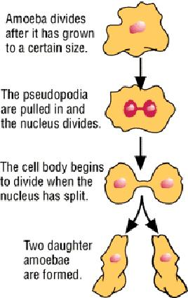A paramecium undergoing binary fission © Shirley Burchill

**Multiple fission (schizogamy)**

This is the splitting of one cell into many daughter cells (schizonts)

This normally takes place in parasitic microbes e.g. one malarial parasite (plasmodium) in a liver cell undergoes multiple fission to produce 1000 organisms.

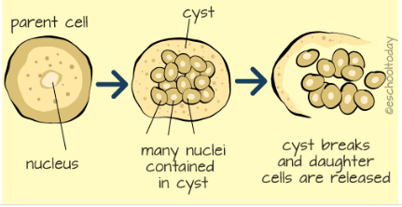

**Sporulation**

This occurs in fungi, algae, protozoa and bacteria. Spores are produced, they are dispersed and will germinate if suitable conditions are present.

A spore is a haploid small reproductive cell usually unicellular capable of developing into an adult without fusion with another cell. It contains some small amounts of cytoplasm and nucleoplasm.

**Sporulation in Rhizopus(common mould)**

A few days after Rhizopusappears on a piece of bread, little black dots are seen. These are the sporangia which are borne at the end of the sporangiophore. Each sporangium contains many small spores, and when it is ripe it bursts and the spores are set free. The spores are very light and easily blown by the wind. If they fall on a suitable substrate they germinate and grow into a mycelium.

**Advantages of spores over seeds in germination**

* Spores have less food store hence light and can be easily dispersed to longer distances from the parent reducing overcrowding and risk of disease spreading
* Spores are more resistant to adverse environmental conditions hence can survive and germinate when conditions are favourable.

**Comparison of spores and pollen grains**

Similarities

* Both are formed by meiosis
* Both are haploid cells
* Both are light and easily dispersed by wind

**Differences**

|  |  |  |
| --- | --- | --- |
| Spores |  | Pollen grains |
|  | No gametes  Can germinate into an independent structure Remain viable for a long time | * They are male gametes * Cannot form an independent structure * Can only be viable for a short time |

**Budding**

This is the type of reproduction in which an organism develops an outgrowth which can detach itself and develop into a new organism. Yeast cells, bryophyllum and hydra reproduce by this method.

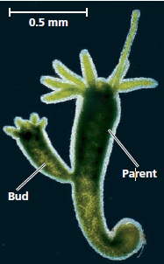

**Budding in yeast**

In suitable conditions i.e. enough food, water, oxygen and optimum temperature, yeast reproduces by budding. Each cell forms a projection or bud and its nucleus divides into two. One part of the nucleus moves into the bud which can detach off the parent or remain attached to form a chain.

**Fragmentation**

This is the type of reproduction in which an organism breaks up into two or more parts and each part forms an independent individual by successive cell division e.g. in spirogyra. This occurs when the conditions are suitable.

Vegetative reproduction/propagation

This is the type of asexual reproduction in which new individuals grow from other parts of a flowering plant other than the flower (vegetativeparts) of a parent plant. Such plant parts contain stored food from the parent plant’s photosynthesis and they are known as perennating organs. These parts are leaves, stems and roots.

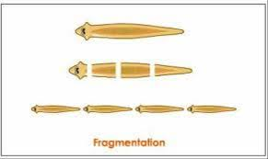

**Stemtubers**

This is the swollen underground stem which stores food.it has terminal buds for reproduction. The young plant grows using food stored in the stem tuber.

**Drawfig21.7 (a)B.Sstemtuberpage704**

**Root tubers**

This is a swollen food storing adventitious root. A root tuber therefore, may have lateral with root hairs unlike stem tubers. Root tubers are organs of peranation only but not for vegetative reproduction. **Drawfig21.9B.Sroottuberpage704**

**Rhizomes**

These may serve as organs of propagation and sometimes also as peranation.

A rhizome is an underground stem bearing leaves shoot and adventitious roots growing from nodes, scale leaves and buds. Unlike tubes, the rhizomes continue growing horizontally from year and season. The rhizome is uniformly swollen along its length the food reserves and its main shoot of the plant. **Drawfig21.4B.Srhizome,page702**

**Runners and stolons**

Stolons are organs of vegetative propagation consisting of a horizontal stem growing along the surface of the ground and have roots at internodes where a new shoot rises. Long and rapidly elongating stolons that root at the tip are called runners e.g. straw berries. **Drawfig21.6B.S, page702**

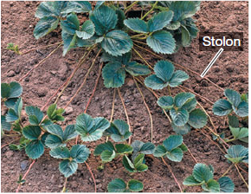

**Corm**

A corm is a short swollen underground vertical stem. It has scale leaves, buds, adventitious roots and the swollen with stored food it is for peranation and vegetative propagation. Drawfig21.3B.S,page703

**Suckers**

These have underground stems(corm) from which short rhizomes grow to produce a clamp of aerial shoots (suckers)close to the base of the parent plant e.g. banana.

**Bulbs**

A bulb is an organ of peranation and vegetative propagation in plants that consist of a modified shoot whose stem is very short and surrounded by fleshy scale leaves (thickened leaf bases that store food e.g. onions).

**Drawfig21.2B.S,page702**

**Artificial propagation.**

This includes

* Stem cutting such as cassava, sugar cane, sweet potatoes.
* Grafting this is used in growing fruit trees like avocado etc.

**Stem cuttings**

This is where part of the plant is removed by cutting and placed in a suitable medium for growth.it produces roots and grows into a new plant. Rooting can be stimulated by a rooting hormone.

**Grafting**

This is the transfer of part of one plant (the scion) onto the lower part of another plant (the stock). The scion is chosen for its fruits and the stock for properties like disease resistance and hardness.

Advantages of asexual reproduction.

1. It produces more off springs than sexual reproduction leading to faster propagation of species.
2. It maintains favorable characters (genes) as the off springs are genetically identical to parents.
3. Resulting off springs mature faster than these produced by sexual means because they already have a large food reserve.

**Parthenogenesis**

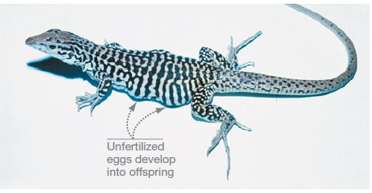

This is the development of a female gamete into a new individual in absence of a male gamete.

Or it is the development of an embryo from unfertilized eggs.

It is a modified form of sexual reproduction since it involves formation of gametes. Gamete are either produced by meiosis or mitosis.

**Types of parthenogenesis**

1. **Diploid parthenogenesis**

This is the development of an embryo from an unfertilized diploid eggs that are formed by mitosis resulting into diploid offspring which are identical to the parent. This occurs in aphids where many wingless females are produced.

1. **Haploid parthenogenesis**

This is the development of the embryo from unfertilized haploid eggs by meiosis and may develop directly into haploid offspring. This occurs in honey bees, wasps, ants etc.

In honey bees, unfertilized eggs develop into drones

**Advantages of parthenogenesis**

* It leads to rapid production of offspring hence rapid colonization • Reproduction is still possible in absence of the male.
* It eliminates the lethal genes that would be present in the homozygous condition.

**Disadvantages**

* No genetic mixing hence reducing viguor
* It produces offspring with low ability to adapt to new conditions

**SEXUAL REPRODUCTION**

This is the mechanism of reproduction in which the nuclei two haploid cells (gametes) fuse to produce a diploid cell (zygote) that develops into a new organism.

If the two gametes from the two different sexes are morphologically similar, they are called **isogametes and** if they are not similar are called **anisogametes.**

When both gametes are present in an individual organism, it is said to be bisexual/hermaphrodite. Monosexual organisms e.g. the majority of mammals have separate sexes. In plants the term monoecius refers to hermaphrodites whereas dioecious refers to Monosexual.

**Sexual reproduction in lower organisms**

**Conjugation**

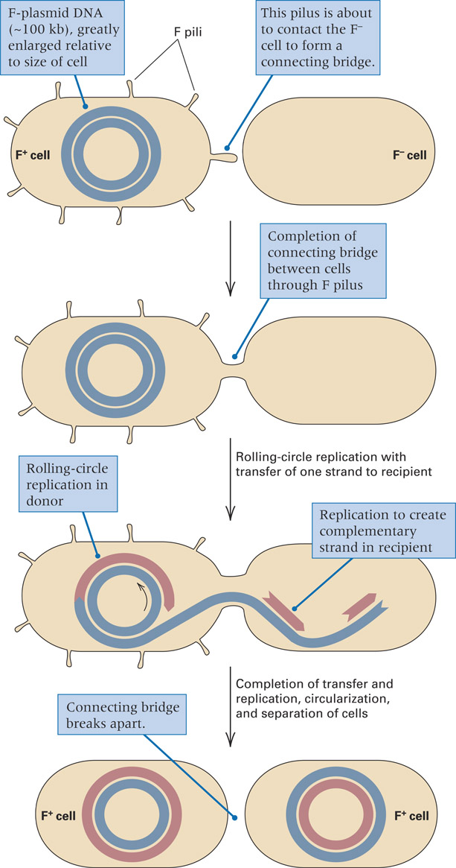

Conjugation is a process in which DNA is transferred from bacterial donor, F+ cell to a recipient, F- cell by direct contact.

The transfer is mediated by a tube-like structure called a pilus, formed between the cells, through which the plasmid DNA passes.

Once in contact, conjugation, DNA transfer is unidirectional. The lagging strand template peels away… and is transferred to the recipient.

The leading strand template is replicated in the donor while the lagging strand template is replicated in the recipient… so that both cells wind up with the plasmid.

**Hfr and Conjugation (**Hfr = high frequency of recombination)

* F factor can integrate into chromosome via genetic exchange between IS elements present in F and homologous copy located anywhere in bacterial chromosome. Cells with the F plasmid integrated into the bacterial chromosome are known as Hfr cells. When an Hfr cell undergoes conjugation, the process of transfer of the F factor is initiated in the same manner as in an F+ cell. However, because the F factor is part of the bacterial chromosome, transfer from an Hfr cell also includes DNA from the chromosome

Transfer begins within an integrated F factor and proceeds in one direction. A part of F is the first DNA transferred, chromosomal genes are transferred next, and the remaining part of F is the last. The conjugating cells usually break apart long before the entire bacterial chromosome is transferred, and the final segment of F is almost never transferred. The recipient cell remains F-

**ALTERATION OF GENERATIONS**

**QN. What is meant by the term alteration of generations?**

Ans:

Alteration of generations is the life cycle of plants which consists of two alternating stages of growth; a haploid gametophyte which produces gametes by mitosis and a diploid sporophyte which produce spores by meiosis. The life cycle is complete when a plant passes through both stages as seen in bryophytes.

In alteration of generations, the life cycle involves two distinct phases.

* The haploid gametophyte- gametes producing plant
* A diploid sporophyte- spore producing plant

The haploid generation is called the gametophyte because it undergoes sexual reproduction to produce gametes by mitosis. The haploid gametes fuse to form a diploid sporophyte generation. It is called a sporophyte because it undergoes asexual reproduction to produce spores by meiosis.

Gametophyte (n) gamete (n)

Saprophyte (2n)spores (n)

The life cycles of pteridophytes (e.g. ferns) and bryophytes (e.g. mosses) show alteration of generations. In ferns, the sporophyte is the dominant stage while in mosses, the gametophyte is the dominant stage.

* The male reproductive organ is called antheridium and produces motile gamete called Oogonium to form zoospore.

**Significance of alteration of generations**

* There is rapid multiplication as spores are normally produced in large quantities
* Spores can survive harsh conditions and germinate when conditions are favourable
* Spores lead to different varieties (variation)since meiosis takes place during spore formation
* Fertilization restores the diploid chromosome number since production of gametes by mitosis ensures that haploid gametes state is maintained
* Ensures that plants colonise different habitats in the ecosystem since spores can easily be dispersed
* The interdependence between the gametophytes and sporophyte generation ensures existence of both generations and avoids extinction of plant species.
* Enables exploitation of different habitats in the ecosystem by the different generations

**Bryophytes e.g. funaria**

**Structure**

It consists of a leaf linked male and female rosette containing antheridia (male) and

Archegonia (female) on which a diploid sporophyte with a stock of sporangium (capsule) at the tip is attached. It has rhizoids which are slender, multicellular branching for anchorage and it lacks vascular tissue and water proof cuticle.

**Life cycle**

It consists of two distinct forms in its life cycle, the haploid gametophyte which is dominant followed by the diploid sporophyte that grows and is dependent on moss plant

The gamete mother cell inside the antheridia and archegonia of the gametophyte generation produces sperms and ova respectively by mitosis.

When mature, the antheridia rapture to release biflagellate sperms which are transferred with the aid of water to the open necks of archegonia through which they swim in a film of water to the egg to effect fertilization forming a diploid zygote which grows into a diploid sporophyte generation that remains attached to and dependent on gametophyte.

The diploid mother cell inside the sporangium divide by meiosis producing haploid spores. When mature, the sporangium bursts open releasing haploid spores to be dispersed by wind. Upon landing on moist ground, spores germinate into a green filamentous protonema which produces buds that grow into a haploid gametophyte generation thus completing the cycle.

**Draw the life cycle of a bryophyte .B.S, fig 2.34 page 39**

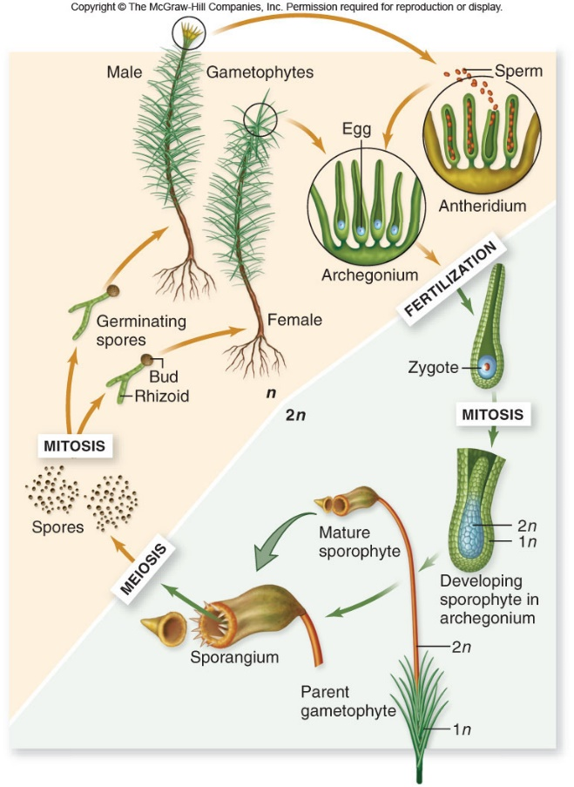

**Limitations faced by bryophytes (mosses) in terrestrial life**

* They lack a water proof cuticle hence prone to desiccation
* Lack a vascular tissue so they face inadequate uptake and transport of water and mineral salts
* They have small sessile leaves which provides a small surface area for trapping sunlight hence reduced photosynthesis
* They are dependent on water to carry gametes for fertilization which may not readily be available in terrestrial habitats.
* They are closely packed which causes spread of diseases and competition for nutrients
* Leaves are pale green implying that lower chlorophyll content hence inadequate for photosynthesis

**Pteridophytes (fern)**

**Structure**

It consists of a large plant with horizontal underground vegetative stem/ rhizome from which vertically growing leaves (fronds) arise

On the underside of the spore bearing leaf lets developed groups of sporangia contained in bodies called sori (sorus-singular) which is covered by a protective tissue called indusium. The dominant generation is the sporophyte with well- developed vascular tissue and water proof cuticle.

**Life cycle**

It consists of two distinct forms in its life cycle, the diploid sporophyte which is the dominant and asexual state and the haploid gametophyte which is the sexual and less conspicuous.

The diploid spore mother cell inside the sporangium of the sporophyte generation divides by meiosis to produce haploid spores when mature the capsule opens and the exposed sporangium wall dries out and raptures releasing the spores. To be dispersed by wind.

Upon landing on moist ground, they germinate to form a gametophyte generation which developes into a prothalusanchoured to soil by Rhizoids that produce a single antheridium and archegonia located on the lower surface.

The gamete mother cells of each divide by mitosis to produce spores and ova respectively, the antheridia then rapture to release multi-flagellatedspermswhich swim through a film of water towards the ova at the base of the archegonia to effect fertilization to form a diploid zygote which grows into a sporophyte generation thus completing the cycle.

**Draw the life cycle of a fern.**

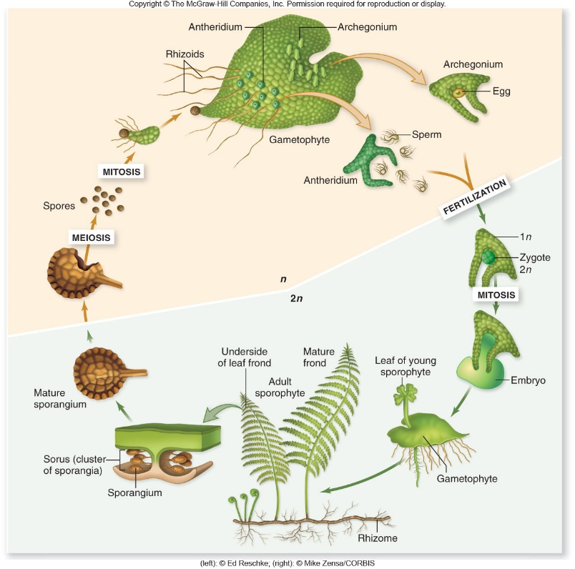

Comparison of the life cycle of a fern and a moss

**Similarities**

* Both life cycle alternate between the haploid gametophyte and diploid sporophyte
* The gametophyte in both bears antheridium and archegonium
* Both produce spores by meiosis
* Sperms in both move towards the ova by positive chemotaxis
* Gametes are produced by mitosis in both
* Both have flagellated sperms
* The ova are non-motile
* Both involve germination of spores into gametophyte

**Differences**

|  |  |  |  |
| --- | --- | --- | --- |
| Life cycle of a moss | | Life cycle of a fern | |
| * Sporophyte is short-lived attached to and dependent on the gametophyte * Gametophyte is the dominant generation * Gametophyte has no true roots, stem or leaves * Spores germinate into protonema which produce buds that grow into gametophyte | | * Sporophyte is self-supporting plant and long lived * Sporophyte is the dominant generation * Sporophyte has true roots, stem and leaves * Spores germinate and develop into gametophyte/ no protonema | |
|  | Protholus absent  No sori/ indisium  Sperms are biflagellated  Sporophyte and gametophyte lack vascular tissue and water proof cuticle |  | Protholus present  Sori/ indisium present  Sperms are multi flagellated  Sporophyte has a well-developed vascular tissue with water proof cuticle |

**Qns.**

1. **How are ferns better adapted to terrestrial life than mosses?**
   * The sporophyte of ferns have true roots for anchorage, transport of absorbed minerals and water which is lacking in mosses
   * Ferns have rhizomes or horizontally underground stems to survive unfavourable environmental conditions
   * Ferns produce more spores than mosses for greater reproductive rates
   * They have broader leaves to present a large surface area for photosynthesis
   * Ferns have true vascular tissue for transport and translocation of materials
   * Ferns’ sporophyte generation are nutritionally independent while that of mosses depend on the gametophyte for nutrients
   * The leaves of ferns have cuticle to present desiccation
   * Ferns have true stem to support the leaves to obtain light
2. Why are bryophytes(mosses) restricted to growing in dump/ wet environment
   * + They depend on water for movement of gametes towards each other for fertilization
     + They lack a well-developed root system and so rely on diffusion to obtain water
     + They lack a cuticle hence need much water to avoid desiccation
     + They lack vascular tissues therefore need water to be supplied to various parts by osmosis.
3. **Why are bryophytes able to grow successfully on land**
   * + They have chlorophyll to trap sunlight for photosynthesis
     + They grow in clusters to strengthen their position in the soil
     + They reproduce both sexually and asexually to increase their chances for survival Revision questions
4. **Describe how plants are adapted to reproduction on land**
5. **Explain how asexual reproduction produces offspring identical to parents**

**Sexual reproduction in flowering plants.**

In flowering plants the reproductive apparatus is embedded in flowers. These structures contain reproductive cells and arise at particular times. In the history of the plant usually in response to specific environmental stimuli such as temperature and day length.

From the reproductive point of view, the flower is a complex mechanism that ensures that seeds for the next generation are produced functionary, a flower consists of the following parts.

1. An outer protective cover of sepals that constitute the calyx. Most are green and carry out photosynthesis. Main function is to protect the flower when still in bud.
2. Appendages normally attractive to insects known as petals constitute the corolla. Terms used to describe the corolla,
   * Polypetalous-when petals are free
   * Gamopetalous- when petals are fused.
3. The anthers which carry the male gametes or the pollen grains. The anthers are born on filament together with which they constitute the stamen. All stamens together make up the male part of the flower called androecium. Terms used to describe the androecium.
   * Monodelphous – stamens united by their filaments to form staminal tube e.g. hibiscus.
   * Diadelphous – stamens united forming two groups e.g. 9+1 in the bean family 9- united,

1- single.

1. The female gamete or ovules protected inside the carpels.

NB. True gametes are sperm nucleus from anthers and ovum from ovules.

Carpels and pistil constitute the gynoecium- the female part of the flower. Terms used to describe carpels.

* + Monocarpous- a pistil with only one carpel.
  + Apocarpous- a pistil with more than one carpel which are free.
  + Syncarpous- a pistil with more than one carpel which are fused Three parts of carpel.
  + Ovary consists ovules
  + Style- stalk connecting ovary to stigma
  + Stigma- end of the style that receive pollen grains.

The corolla and calyx constitutes where they appear alike the perianth.the gynoecium and androecium are the most essential parts of the flower the rest are accessories.

* + Carpelate – flowers which lack androecium
  + Staminate – flowers which lack gynoecium.

**Carpelate and staminate flowers are unisexual**. Flowers with both stamens and carpels are hermaphroditeplants which are either hermaphrodite or have both pistillate and staminate flowers are monoeciuse.g. maize, peas etc. plants with only pistillate or staminate flowers per plant are dioecious e.g. pawpaws

**A complete flower.**

This is one in which all the four floral whorls, calyx, corolla, androecium and gynoecium are present. If one or more of these are absent, the flower is referred to as an incompleteflower.

A perfect flower is one with both androecium and gynoecium even if it lacks calyx or corolla. A flower is in an angle between the stem and the leaf like bract. Flowers are symmetrical or asymmetrical. Radiary symmetrical flowers are actinomorphic (regular), bilateral symmetrical flowers are zygomorphic (irregular)

## **Vertical section of a generalized flower.**

**Drawfig21.16B.S,page713**

## **Development of pollen grains.**

An anther contains four pollen sacs in which pollen grains develop.

* Each pollen sac has a mass of pollen mother cell, all of which are diploid.
* These microspore mother cells give rise to microspores which produce tissue yielding the gametes.
* Microspores divide meiotically to give four haploid pollen grains with in each of which mitosis gives rise to two nuclei, the generative nuclei and the pollen nuclei.
* The generative nucleus will later develop / divide mitotically to give two sperm nuclei during pollination.
* The walls of each cell divides then develop into a thick, highly sculptured outer wall called exine and a thinner inner wall called intine to become a pollen grain

**Drawfig21.21and21.22B.S, page717**

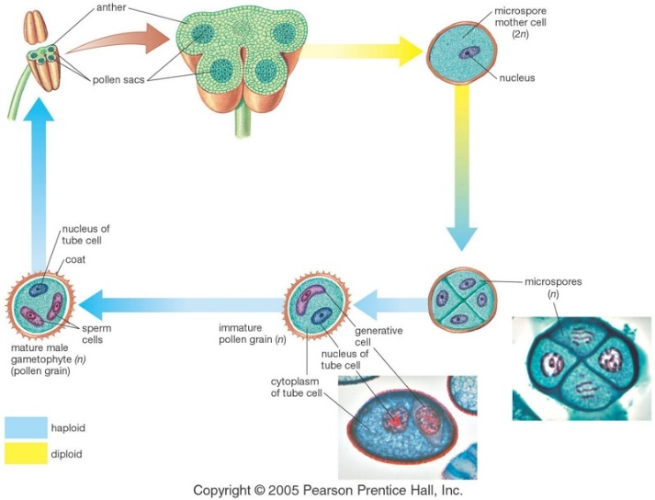

Qn

**Outline the events that lead to formation of pollen grains in flowering plants.**

**Development of the embryo sac/ ovule in the ovary**

In a maturing ovary,

Megaspore mother cell enlarges and undergoes meiosis, producing four haploid megaspores.

Only one megaspore survives; the others degenerate. One megaspore undergoes three successive mitotic divisions to form 8 nuclei

Six of the 8-nuclei get surrounded by the cell wall and the remaining two, called polar nuclei , are situated below the egg apparatus in the large central cell .

● Three of the six cells are placed at the micropylar end and constitute the egg apparatus (2 synergids + 1 egg cell ).

Three cells are at the chalazal end, and are called antipodal cells .All the haploid cells disintegrate except the egg cell and the 2 polar nuclei.

**Draw fig 21.24B.S,page718**

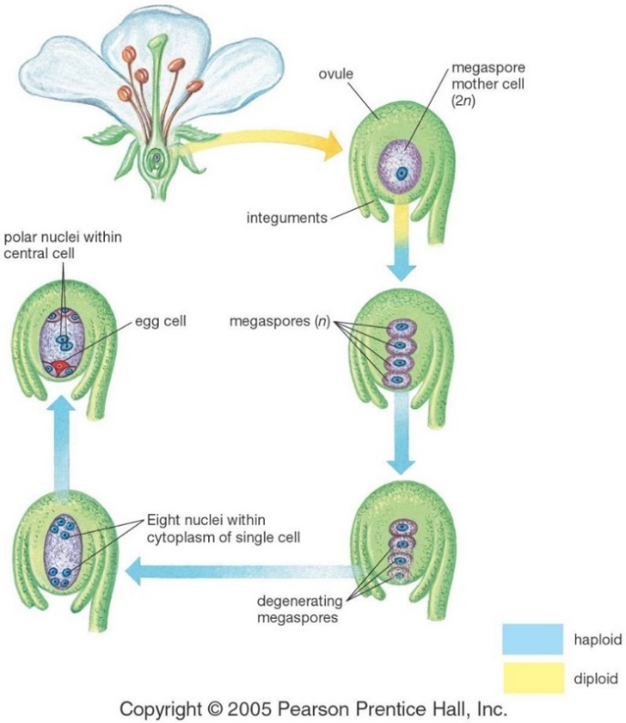

**Qn. Give an account of the process of gametogenesis in a flowering plant**

**Comparison of embryo sac and pollen grain formation**

Similarities

* Both involve mitosis and meiosis
* Both begin with a diploid cell
* Both result in haploid cells
* Both are protected externally i.e. ovules by interguments and pollen grain by exine.

Differences

|  |  |  |  |
| --- | --- | --- | --- |
| Pollen grain development | | Embryo sac development | |
| • Begin in the pollen sac from the pollen | | • Begins as a small swelling in the ovary wall | |
| * • * • • | mother cell  All products of meiosis develop into pollen grains  The haploid nucleus divides once to give rise to the nuclei  The whole cell is functional in reproduction  No migrations occur  Protected by thick outer wall  Numerous products formed  Product is smaller | * • • | to form the embryo sac  Only one of the four products of meiosis develops into the embryo sac  The haploid nucleus divides by mitosis three times  Only the egg cell is functional in reproduction  Nuclei migrate and re arrange in the embryo sac  Protected by interguments  Fewer products formed  Product is larger |

## **POLLINATION**

The process of pollen transfer from anthers to stigma (pollination) is normally affected by:

* Wind (anemophilous flower)
* Insects (entomophilous flower)

The line of weakness in the anther wall split/ dehisce when the wall of the anther dries causing shrinkage of the cells. Then the pollen grains are released and transferred from anthers to the stigma.

Self-pollination may occur by usually wind, insects and rarely water may convey the pollen grains to the stigma (cross pollination) of a similar but a separate plant.

The sugary fluid nectar secreted by the glandular nectarines at the base of each petal serves as a bait to insects.

**Characteristics of entormorphilous flowers/ insect pollinated**

1. Large, brightly coloured and often scented petals. If small aggregated in numbers to form a broad expense of colour against the back ground for attraction.
2. Contain sugary nectar.
3. Are strongly scented and conspicuous.
4. Possess sticky stigma
5. Poses small anthers, compact and firmly attached filament held in position to get in contact with visiting flowers.
6. Have pollen guides and landing plat form for insects e.g. orchids and leguminous flowers.
7. Some flowers are shaped in a way that insects come into contact with reproductive parts.
8. Produce sticky pollen grains

**Characteristics of anemophilous flowers/ wind pollinated flowers**

1. Are usually small and inconspicuous
2. Are small but exposed with many different shapes/have large inflorescences.
3. Are usually dull cultured.
4. They nectar and are not scented
5. Their stamens produce large quantities of light powdery and smooth pollen grains.
6. Anthers are large and loosely attached to long filaments.
7. Have large stigmas and feathery that hang outside the flower.

**CROSS POLLINATION**

It is a more effective method of producing new variations than self-pollination.

Hybridization by plant breeders is effected by transferring pollen grains from one plant to another by a brush.

Cross pollination is more common than self-pollination. Many plants have mechanisms that encourage cross pollination but allow self-pollination to occur if cross pollination fails.

In self-pollination, the disadvantage is that since there is self-fertilization, no new characters are introduced in the off spring, no variation also this is a disadvantage in asexual reproduction. Cross pollination leads to cross fertilization i.e. mixing of characters.

It introduces more variation in off springs and result in increased survival rate.

**Mechanisms that result in cross pollination / hinder self-pollination**

1. Possession of unisexual flowers on dioeciouos plants e.g. pawpaws
2. Self-sterility in monoecius plants like maize
3. Failure of both stamen and pistil of a bisexual flower to mature at the same time. This condition is called dichogamyi.e. maturation of anthers and stigma in a flower at different times.
   * The condition in which anthers (stamen) mature first is protandry
   * The condition in which stigma (pistil) matures first is protogamy

It is rare though effective in ensuring cross pollination only.

**Mechanisms that result into self-pollination**

1. Maturation of both stamen and pistil at the same time
2. Flowers found (born) underground e.g. g.nuts
3. Flowers being hermaphrodites e.g. hibiscus
4. Flowers never open at all e.g. commelina. This condition is called clestogamyi.e. flowers do not open at all.

The formation of large conspicuous flowers that are adapted to cross pollination usually by insects is known as chasmogamy.ie do not open at all.

Some plants have only cross pollination with an incompatibility mechanism i.e. they are self-sterile (dioecism to make selfing absolutely impossible.)

In dioecism, a plant species have separate male and female flowers occurring in separate flowers.

**Self-sterility**

This mechanism ensures that pollen does not grow on the stigma of the same plant or on the genetically identical one.

**Questions**

1. **(a) state the adaptations of flowers to pollination**

* 1. **Explain the mechanisms which limit breeding in monoecius plants**
  2. **What are the consequences of cross pollination and self-pollination**

# **Consequences of self-pollination**

• Promotes homozygozity i.e. transmission of the same genotype in the population over generations resulting into reduced fertility, reduced resistance to diseases thereby reducing the evolutionary potential of the species in the long-run. This reduces variation which lead to loss of vigor.

# **Consequences of self-pollination**

• Promotes genetic diversity or formation of new combinations resulting into hybrid viguor causing increased resistance to diseases, high yield and earlier maturity there by provides greater evolutionary potential.

2. **(a).Give one ecological importance of each of the following structural arrangements in plants**

1. **monociousness**
2. **dioeciousness**

**(b) Explain why**

1. **In dioecoiuos plants, male plants are usually associated with dry soils while female plants are associated with moist soils**
2. **Nearly all dioecious plants are wind pollinated**
3. **Suggest why dioecious plants are rare than monoeciuos plants despite the advantages of cross pollination**
4. **Why is dioecism/ separate sexes common in animals than in plants?**

**FERTILISATION IN FLOWERING PLANTS**

On arriving at the right stigma, the pollen grain absorbs water and germinates by producing a pollen tube, which grows towards the ovary.

Generative nucleus divides by mitosis and produces two sperm. Tip of the pollen tube grows toward the micropyle in response to chemical attractants produced by the synergids.

The arrival of the pollen tube initiates the death of one of the two synergids, thereby providing a passageway into the embryo sac.

The tube nucleus and the two sperm are then discharged from the pollen tube

1st male nucleus fuses with the egg cell resulting in a diploid zygote (2n) (1stfertilization).

The 2nd male nucleus fuses with 2 polar nuclei to form a triploid endosperm (3n) (2ndfertilization) which develops endosperm /cotyledon.

This is double fertilization since two fusions of nuclei occur.

**Germination of pollen grain and growth of pollen tube.**

**Draw fig 21.25 B.S, page 718**

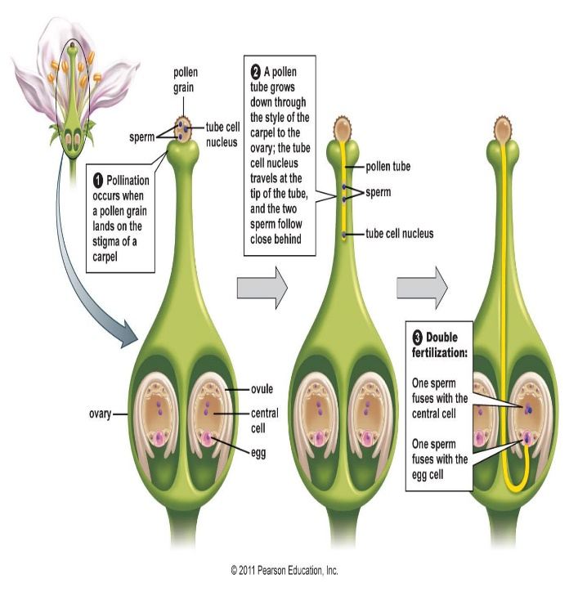

**Events after fertilization**

Fertilization is the climax of the reproductive process.

1. The triploid endosperm nucleus divides by mitosis and absorbs nutrients from the parent plant to form food store the endosperm.
2. The diploid zygote divides to form an embryo made of plumule, radical and cotyledon.
3. The integuments become lignified to form a protective coat called testa (outer integument) and tegmen (inner integument)
4. Ovary swells to accommodate developing embryo and becomes the fruit.
5. The ovary wall becomes the fruit wall (pericarp)
6. The stigma, style and other nuclei disintegrate 7. The flower stalk remains and becomes the fruit stalk

8. The micropyle remains.

N.B Water content of the seed falls by 75% and seed becomes dormant. This dehydration is controlled by plant hormone ABA (absciscic acid). Its development stops but viability remains. Viability = capable of living.

**Qn.**

**(a).Describe the process of fertilization in higher plants**

**(b) Outline the events that take place after fertilization.**

## Differences between fruits and seeds

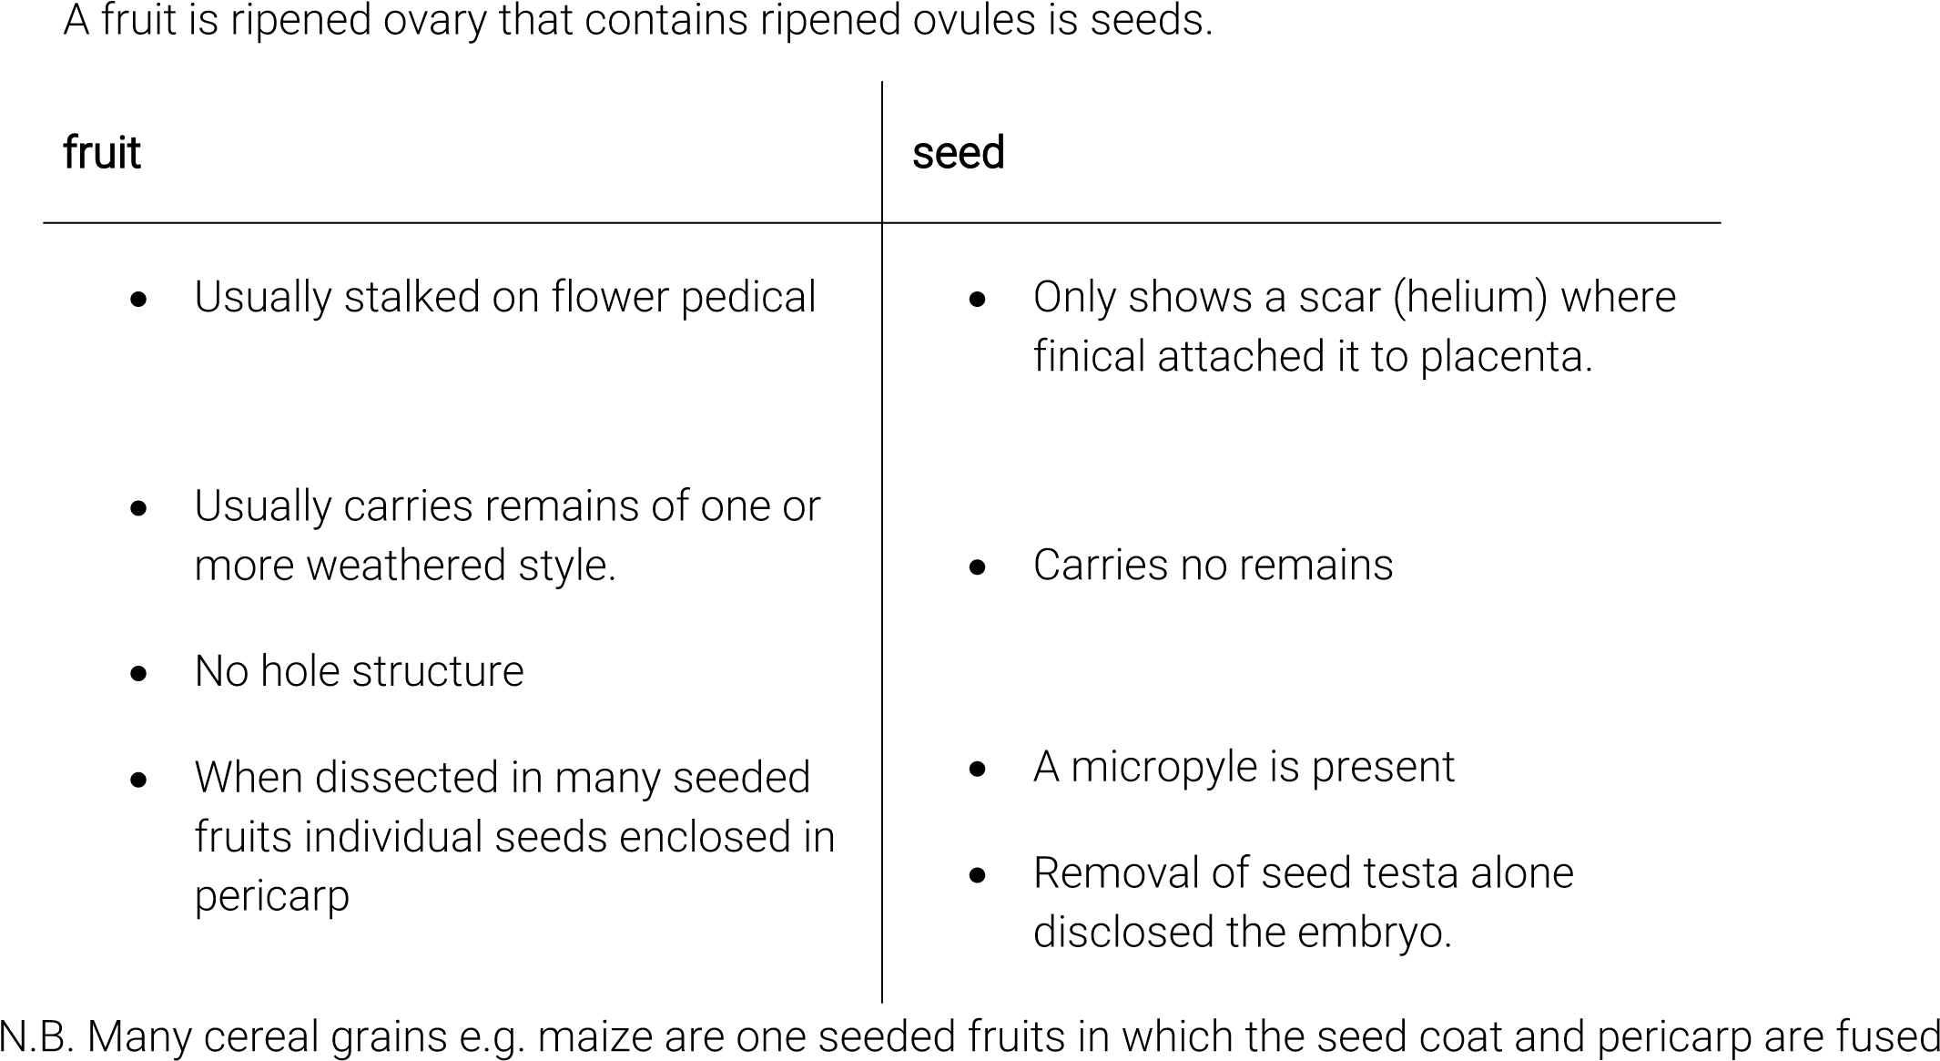 together.

## **FRUITS AND SEEDS**

A fruit is a fertilized ovary only if it results from sexual reproduction.

A fruit is also a developed ovary of a flower containing ripe seeds. Some fruits develop from un fertilized ovaries by parthenocarpy.

**Classification of fruits**

There are two groups of fruits

* True fruits
* False fruits

True fruits develop from ovary of a flower after fertilization. False fruits develop from association of ovaries and other plant parts e.g. parthenocarpy fruits and pineapples.

A true fruit has two scars i.e. remains of receptacle and remains of style.

**Fruits can also be classified into three groups**

1. **Simple fruits.**

These are formed from one flower in which the pistil consists of either one carpel or several carpels joined together e.g. beans.

1. **Aggregate fruits.**

These are formed from one flower in which pistil consists of several free carpels e.g. straw berry.

1. **Multiple fruits**

These are formed from several flowers and their ovaries become fused after fertilization e.g. pineapples.

Simple fruits are further subdivided into three categories

1. **Dry dehiscent fruits.**

Their pericarp is dry and splits open to release seeds along lines of weakness called suturese.g. beans.

1. **dry indehiscent fruits**

Their pericarp is dry and does not split open to release seeds e.g. maize.

1. **Succulent.**

These have fleshy pericarp e.g. mangoes, tomatoes etc.

## **Succulent fruits are divided into 2 categories**

* Berry. Have seeds and are fleshy throughout e.g. tomatoes guavas etc.
* Drupe. Have single large seed enclosed in hard endocarp e.g. mangoes, ovacadoes etc. Classes of dry indehiscent fruits
* Achene. Examples – sunflower ,bidens pilosa, simple fruits consist of one seed surrounded by dry pericarp.
* Caryopsis .examples maize simple fruit one seeded pericarp and seed coat fused together.
* Nut example cashew nut, the pericarp is very hard.
* Cypsela example tridax; calyx persist to form a parachute of hairs called a pappus.
* Samara examples- elm “merkamia” pericarp extended to form wings. Classes of dry dehiscent fruits • Follicle example – cassia; splits along one suture.
* Legume examples.- bean splits along two sutures
* Capsule-examples- castor oil, tobacco. Splits longitudinally along many sutures.
* Schizocarp. Examples Desmodium. Breaks up into many parts each containing one seed.

## **Fruit and seed dispersal**

Dispersal is the transfer and scattering of fruits and seeds from the parent plant. Importance of dispersal

* Results in colonization of new areas
* Helps to stop overcrowding among members of the same species
* Helps to reduce/ stop competition for water, mineral salts, light, space etc.

**Dispersal by wind such fruits and seeds are:**

* Small and light
* May have a pappus of hairs
* May have wing like structures

E.g. tridax and cotton

**Dispersal by animals. They are:-**

* Succulent to attract animals with bright colours
* Have sticky hairs
* Their seeds resist digestive enzymes of animals

# E.g. Bidens pilosa, Achyranthesus aspera, guavas, tomatoes etc.

* Water

Have fibrous pericarp with many air spaces for buoyancy e.g. palm trees, mangrove, water lily etc.

* Explosive mechanisms

When fruits dry they split and disperse/ release seeds e.g. peas and beans.

**Dispersal by chance**

This is dispersal by agents other than those which the seed/ fruit shows special modification e.g. mud in animal feet can disperse small seeds

Man is the greatest agent of seed dispersal due to his agricultural process.

Dispersal is followed by germination of seeds if they fall in suitable media.

## **SEXUAL REPRODUCTION IN MAMMALS (man)**

Sexual reproduction is the production of new individuals by fusion of two nuclei from different parental organisms, male and female contained in sex cells called gametes.

## **Sources of genetic variation in sexual reproduction**

* Cross over of genes between chromatids of homologous chromosomes may occur during prophase I of meiosis producing new linkage groups and new gene combinations
* Independent assortment during metaphase, the orientation of chromosomes on the spindle equator is random allowing independent segregation of homologous chromosomes resulting into large possible chromosomal combinations in gametes.
* The fusion of male and female gametes is also random allowing varied characteristics in the off springs

**Under what circumstances may variation not occur in sexually produced individuals?**

* When crossing over doesn’t occur during meiosis when the gametes are formed, fusion of such gametes produces identical off spring
* When fertilization occurs between closely related individuals, the off springs produced may not show much variation
* In hermaphroditism where one parent is involved

**Methods of fertilization in animals**

* + Internal fertilization
  + External fertilization

|  |  |
| --- | --- |
| External fertilization | Internal fertilization |
| * Larger number of gametes are produced(sperms and ova) * Off spring are not well protected by parents * Off spring are helpless when still young | * Large number of gametes are not necessary except the sperms * Off springs protected with in the mothers body/ pouch * Off spring are born when developed |

**Advantages of internal fertilization**

* + It ensures greater chances of sperms meeting the ova hence minimizing wastage of gametes
  + The developing embryo is well protected inside the mother’s body
  + Internal fertilization can occur at any suitable time in the environment

**Disadvantages**

* Few eggs are ready for fertilization hence few off springs at a time

**Advantages of external fertilization**

* It results in large numbers of off spring since they produce large numbers of eggs and sperms

**Disadvantages**

* Fertilization of eggs depends on chance of collision among the closely placed gametes
* Development of the zygote takes place in water with less protection hence only few may reach maturity
* Fertilization only takes place in presence of a prominent water body

**MALE REPRODUCTIVE SYSTEM**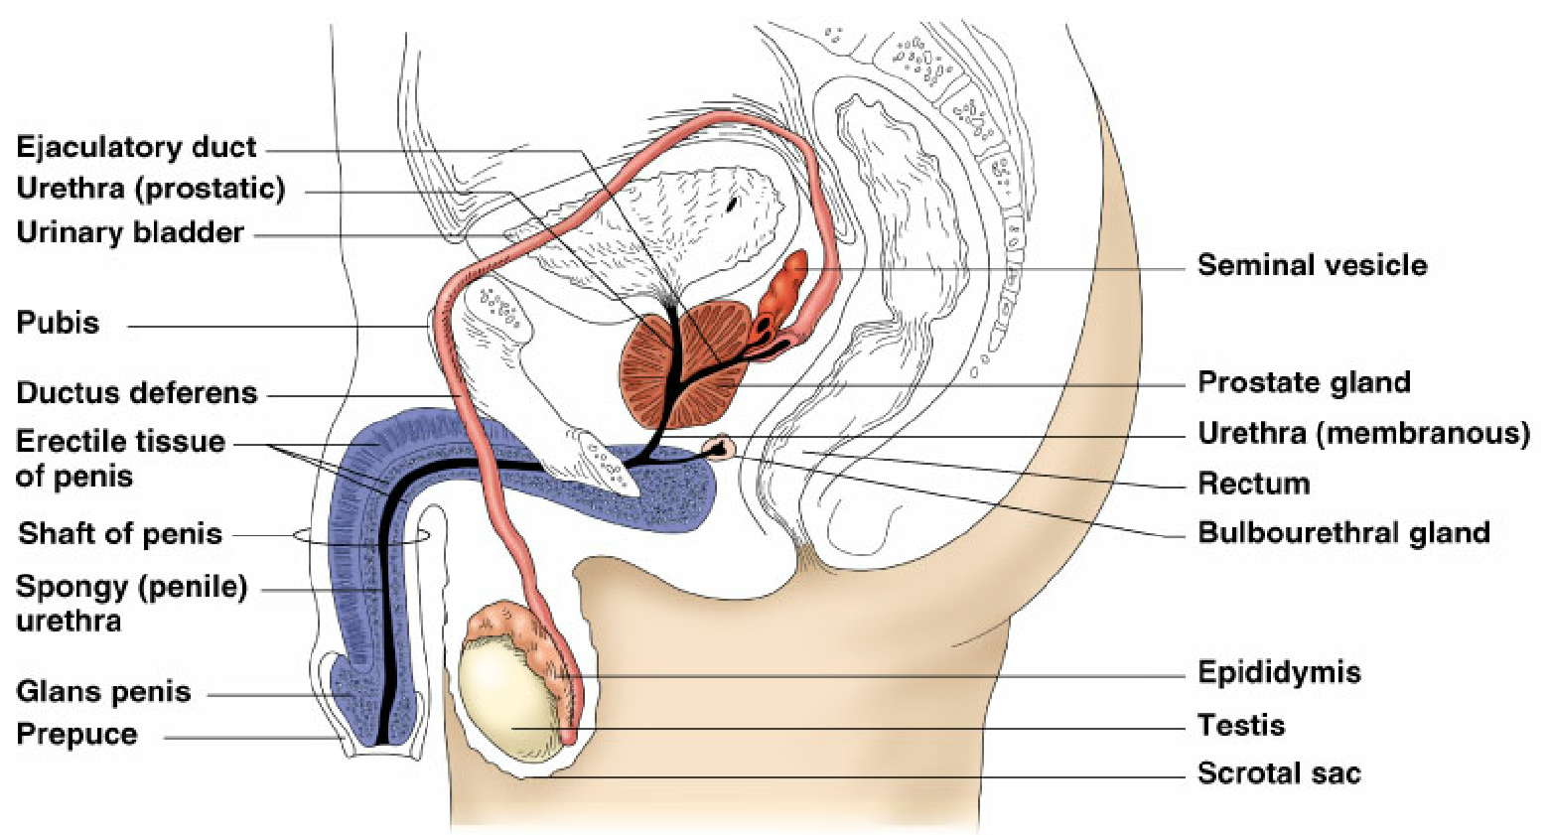

**The two testes /gonads are the primary sex organs which function to**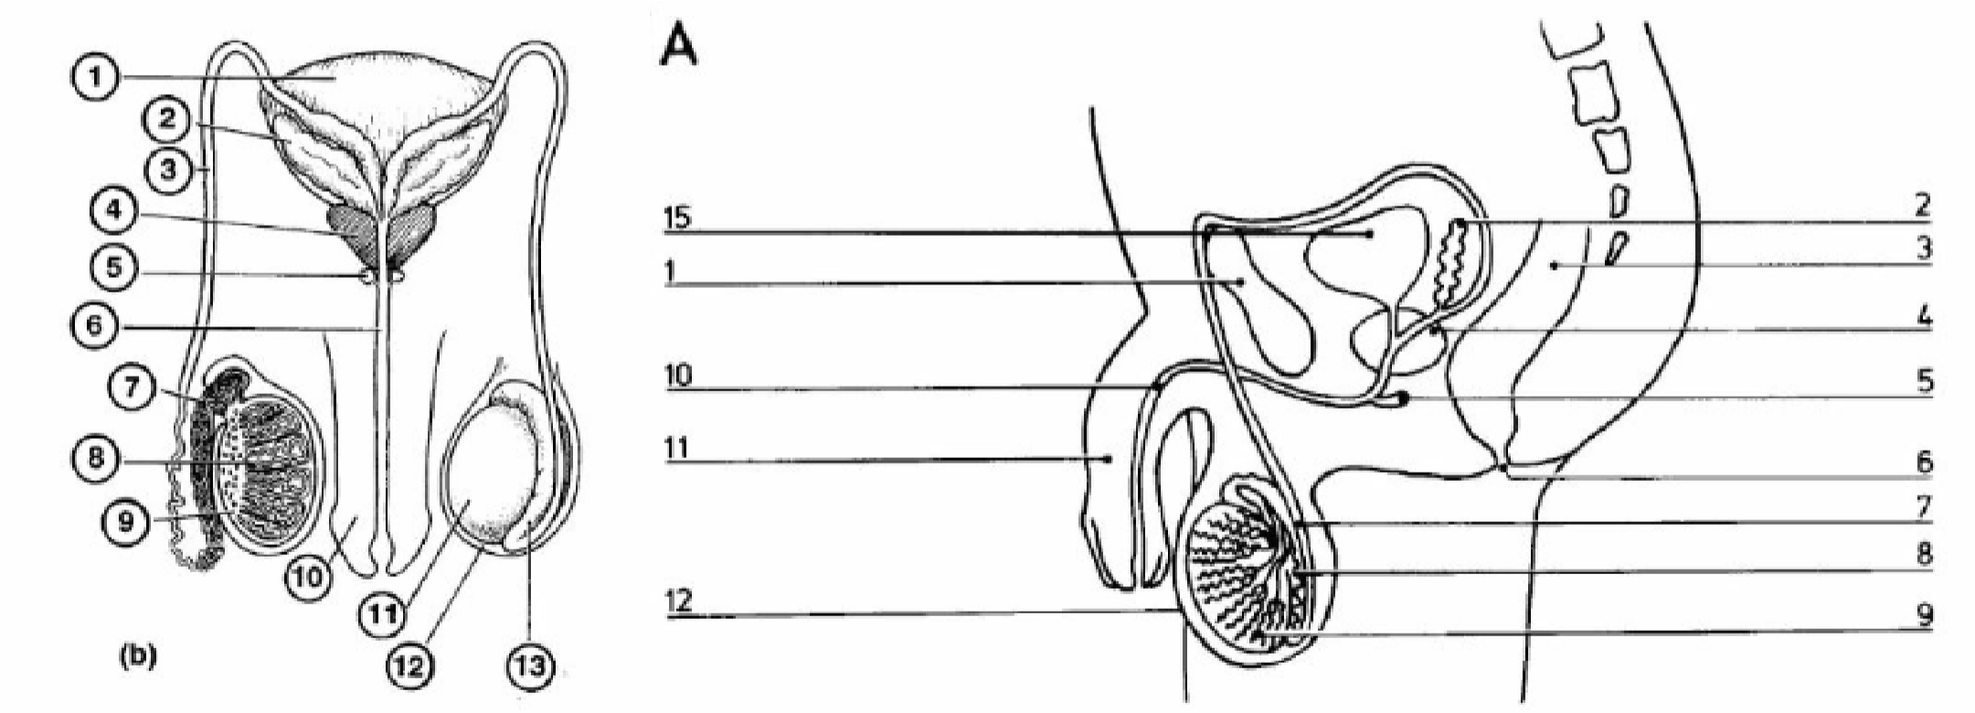

* Manufacture the gametes – spermatozoa
* Delivery of sperms into the female
* Production of male sex hormones called testosterone Testosterone has two functions.
  + For the development of puberty of secondary sexual organs
  + For development and appearance of secondary sexual characteristics
* **Epididymis**- to store spermatozoa
* **Vas deferens**- to transfer sperms from testes
* **Prostate glands-** alkaline fluid for successful fertilization
* **Cowper’s gland**- produce mucus to lubricate male urethra and female birth canal
* **Seminal vesicles-** secrete fluid medium for transport of spermatozoa.

NB the viscous secretion of seminal vesicles is rich in fructose necessary to keep spermatozoa alive and motile.

The prostate gland is large and produces a thin alkaline secretion which neutralizes any acidic urine remaining in the urethra and also to neutralize any acidic secretions of the vagina after the sperms have been introduced into the female.

Epididymis is also a site of storage of the spermatozoa.

Secondary sexual characteristics

* Deep voice
* Pubic, auxiliary and facial hair
* Characteristic male shape of the body
* Wet dreams
* On set of production of sperms

The gonads produce testosterone after they have been stimulated by interstitial cell stimulatory hormone from anterior pituitary gland (ICSH). ICSH (in males) is also known as LH (luteinizing hormone) in females.

**GAMETOGENESIS**

Gametogenesis is production of gametes. It takes place in gonads (testes in males and ova in females). It is spermatogenesis in males and Oogenesis in females.

**Spermatogenesis.**

This is the production of spermatozoa by division of cells of the germinal epithelium due to meiotic divisions.

During their formation, gametes are haploid although the original cell called primordial germ cells (PGC) are diploid (2n).

The primordial germ cells in their germinal epithelium undergo repeated mitotic divisions to form diploid spermatogonia.

Under the nourishing influence of the cells of sertoli each spermatogonia increases in size to form a primary spermatocyte. This then divides meiotically, the first meiotic division giving two secondary spermatocytes and as a result of second meiotic division by each of these four haploid spermatids are formed from each primary spermatocyte.

The Golgi body plays some role in the development of spermatids into mature spermatozoa.

The mature spermatozoon is complete with the head and tail and lies in the fluid secreted inside the seminiferous tubules awaiting transfer to the ovum.

Spermatogenesis summary

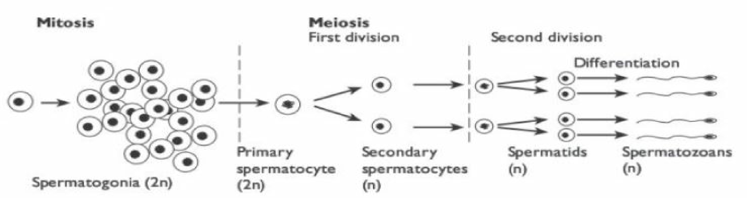

Human spermatozoon

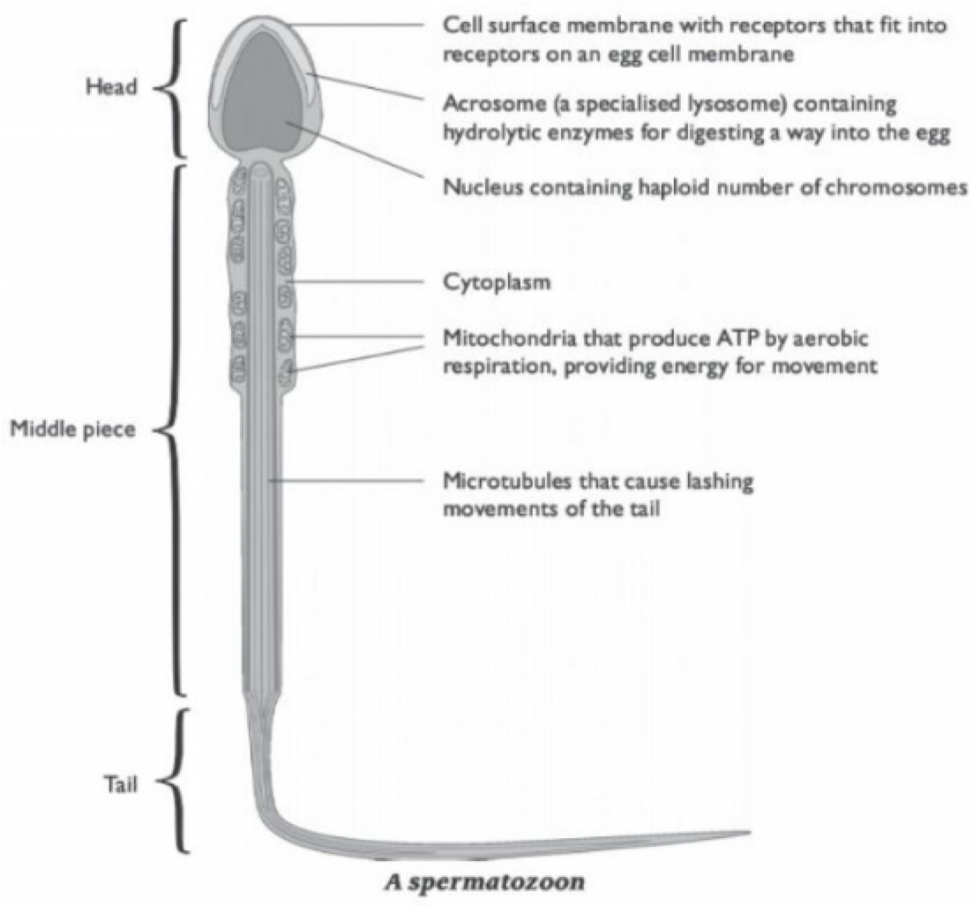

Each primary spermatocyte gives rise to four functional gametes each of which is haploid (n). A mature spermatozoon about 0.1 nm appears swimming freely in the seminiferous tubules.

The development of spermatozoon from the spermatide is a form of metamorphosis involving a loss of almost all the cytoplasm leaving an almost naked nucleus surrounded by little cytoplasm that forms a trail.

## **FEMALE REPRODUCTIVE SYSTEM**

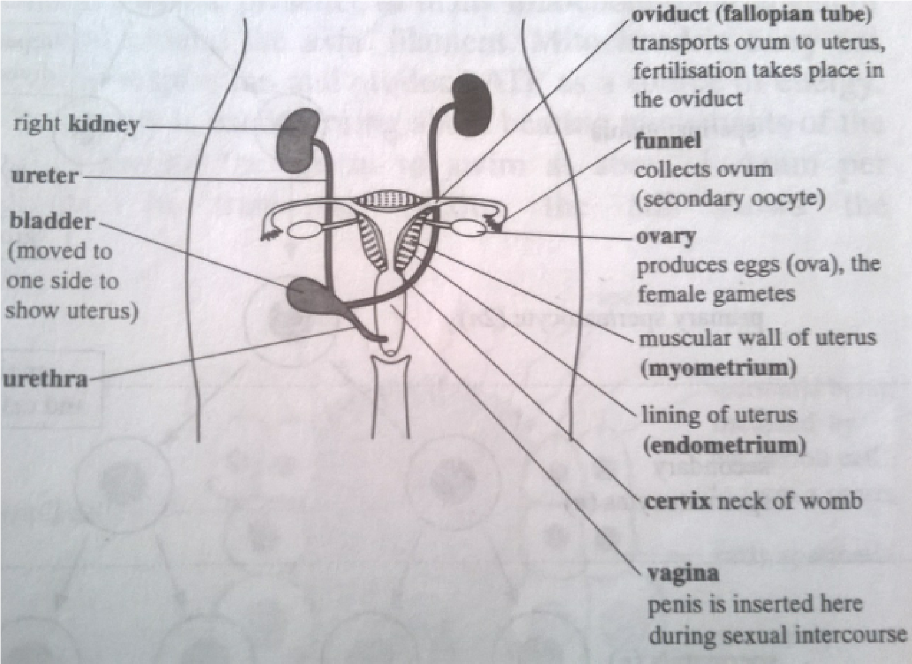

**GENERAL FUNCTIONS OF FEMALE REPRODUCTIVE STRUCTURE**

* Production of ova (femalegamete)
* Reception of male gametes (sperms)
* Secretion of female sex hormones
* Provide suitable fertilization environment
* Foetal development
* Passage of urine(not a reproductive function)

**The gonads are ovaries which are responsible for :-**

* Production of female sex hormones oestrogen and progesterone
* Production of ova (oogenesis)

**Primary sexual organs include:-**

* Fallopian tubes (oviduct)- for transfer of ova from ovaries
* Vagina – for reception of male gametes
* Uterus (womb) for the nutrition and development of the fertilized ovum into foetus.
* Mammary glands- for nutrition of a baby after birth.

**Oogenesis.**

This is the process for the production of ova. Each ovum originates from the primordial germ cells of the germinal epithelium of the surface of the ovary.

It starts during embryonic growth and millions of gamete mother cells ( oogonia ) are formed in the foetal ovary.

● These cells undergo meiosis, but get temporarily arrested at the prophase and are called primary oocytes .

● Before reaching puberty, a large number of primary oocytes degenerate and the remaining ones get surrounded by layers of granulosa cells and new theca and are called secondary follicles .

● The secondary follicles are then converted into tertiary follicles that have characteristic fluid-filled cavity called antrum. At this stage, the primary oocyte present within the tertiary follicle completes meiosis, which results in the formation of haploid secondary oocyte and a tiny polar body.

● This tertiary follicle further changes into the Graafian follicle . The secondary oocyte is surrounded by the zone pellucida.

● Then the Graafian follicle ruptures to release the ovum by ovulation.

Summary of oogenesis

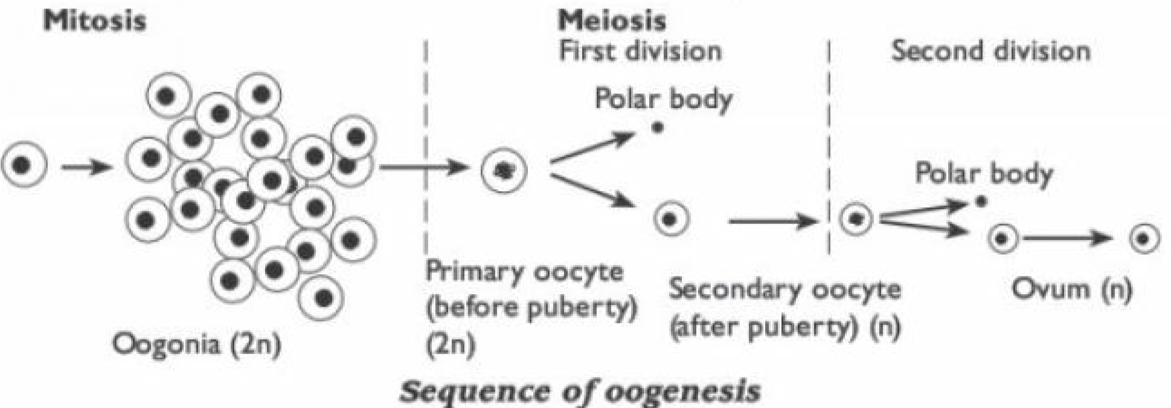

NB. In oogenesis, three polar bodies are produced and one functional egg /ovum from each primordial germ cell.

The grafian follicle secretes oestrogen which maintains sexual characteristics in the 1st half of (14 days) menstruation cycle and prepares for ovulation and prepares for conception.

If there is no fertilization, corpus luteum shrinks and becomes a scar like corpus albicans and progesterone production stops by 24th day.

If there is fertilization progesterone production continues by the corpus luteum for about four months and then the placenta takes over.

Placental progesterone maintains pregnancy.

**Draw the structure of ovum**

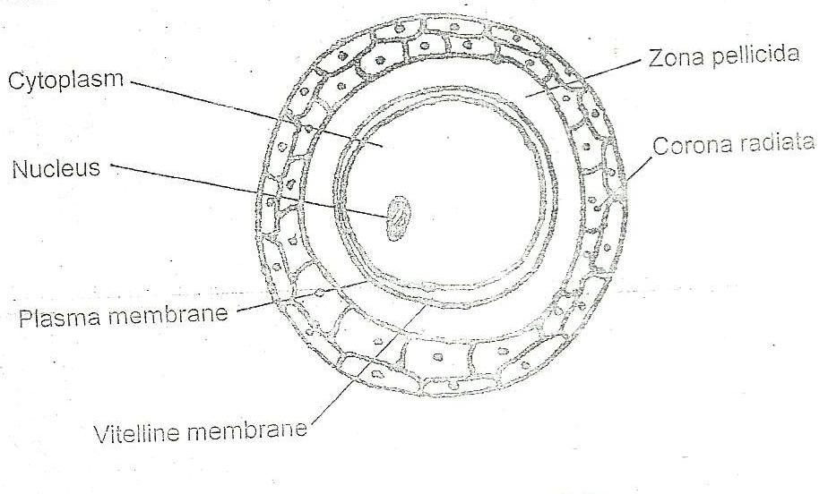

**Comparison of spermatogenesis and Oogenesis**

**Similarities**

* Both involve two processes, meiosis and mitosis
* Both result in production of haploid gametes –sperms and ova
* Both occur in gonads- testes and ovary
* Both start with diploid primordial germ cells Differences

|  |  |
| --- | --- |
| spermatogenesis | Oogenesis |
| * Every spermatocyte develops into 4 spermatozoa * All spermatogonia develop into primary spermatocyte * No polar bodies are formed | * Every primary oocyte develops into only one functional ovum * Only one Oogonium develops into primary Oocyte * 3 polar bodies are formed |

## **COPULATION /SEX INTERCORSE**

During copulation, the sensory cells towards the end of the erectile penis are stimulated repeatedly and create erotic excitement which at coitus triggers off reflex causing contraction of the vas deferens.

Erectility of the male copulatory organ is enabled by dilation and constriction of its arteries and veins respectively.

Contraction of vas deferens sweeps the sperms into the urethra where they mix with secretions from seminal vesicle (rich in fructose) for respiration and prostate glands which maintain the sperm in viable and motile state.

The semen mixture is expelled from the penis during ejaculation by powerful contraction of urethra.

During this process, urine contamination is automatically prevented.

At orgasm (climax ejaculation) enough force projects the sperms into the top of the vagina and even through the cervix to the uterus.

**Fertilization**

Fertilization is the fusion of the cytoplasmic material (plasmogany) and the nuclear material (karyogamy) of 2 gametes to produce a composite cell called zygote.

It follows the union of two parents in sexual inter course (copulation) and the vital and significant feature of sexual reproduction.

NB. There is no sexual intercourse in fish and amphibians, so fertilization is external in these animals.

The ova remain viable for approximately 3 days and the sperm can remain alive for 3 days inside the woman.

Movement of the ovum in the oviduct with the finger like projections called fimbria is by cilia lining its walls. Sperms swim using their tails and muscular contraction of the birth canal. Fertilization occurs in the upper end of the fallopian tube.

**Stages of fertilization**

1. Sperm penetration.

When the head of the sperm gets into contact with the jelly coat of ovum, its acrosome raptures releasing the enzymes that hydrolyse glycoprotein in the vitelline membrane allowing the sperm to enter i.e. acrosome reaction. Sperm enters by its head, tail breaks off that it remains outside the egg.

1. **Thickening of the membrane**

When a sperm enters the vesicles on the surface membrane of ovum (oocyte) discharges contents into the space between plasma membrane and jelly leading the membrane to become thick. This prevents entry of more sperms into the ovum.

1. **Fusion of male and female nuclei**

Nuclear membranes of both gametes disintegrate, spindle fibres form chromosomes of gametes arrange themselves on equator of the spindle forming a zygote. Pregnancy

As the ovum is fertilized conception has taken place. Zygote undergoes several mitotic divisions forming the blastocyst.

The outer most layer of the blastocyst is called trophoblast and it helps in implantation at 6 days after fertilization.

Trophoblast cells form the placenta. Amniotic cavity begins to form in the second week.

The umbilical cord is then formed from endomentrium of the mother e i.e. mother to foetus. Umbilical cord consists of umbilical artery and umbilical vein. Umbilical artery carries blood from the foetus aorta to placenta i.e. deoxygenated blood. Umbilical vein carries blood from placenta to the posterior venacava of the foetus rich in oxygen, glucose, amino acids, lipids, vitamins, hormones, antibodies and water.

The placenta develops a membrane called amnion surrounding embryo in the amniotic cavity filled by the amniotic fluid to protect the embryo from mechanical shock.

**Birth**

Embry moves with in the steros to upside down position during development.

Prostaglandin hormones cause intense labour pains. Oxytocin from posterior pituitary also cause continuous contractions of uterine walls and cervix until the child is born. Later placenta is detached from uterus wall and expelled as the after birth. Oxytocin hormones also stimulate growth of milk secreting glands in mammary glands. After birth, milk production is induced by prolactinhormonefrom the anterior pituitary lobe. Prolactin hormone is inhibited by Oestrogen and progesterone.

**Foetal blood circulation (drawfig 21.58 B.S page 747)**

Gestation period of some mammals

|  |  |  |
| --- | --- | --- |
| Mammal | Gestation period(days) | Litter size |
| Human  Cow  Chimpanzee  Lion  Cat  Rabbit | 267  282  228  108  63  28 | 1  1  1  3  4  6 |
| Mouse  Dog  Elephant | 19  61  624 | 6  7  1 |

**NB. Large animals have longer gestation period and small litter size.**

**Ovulation**

This is the release of ovum from the ovary to the fallopian tube. There are two types of ovulation.

* Spontaneous ovulation
* Induced ovulation

**In induced ovulation**

Coitus/ sexual intercourse is essential to prove the release of ovum.

**In spontaneous ovulation.**

Release of egg follows a regular sequence of events controlled by hormones.

Other factors that may affect/ influence ovulation include

* **Day length**
* Social interactions e.g. stressed female by hunger, fear, anger, sorrow, no ovulation may take place.

Conditions that determine gestation period.

1. The number of young ones in the litter.

**Monotoccus- produce one**

**Polytoccus – produce many**

The more in a litter, the shorter the gestation period e.g. mammals which produce very many in a litter have a short gestation period.

1. **Size of young to be born**
2. **State of development of embryo at birth**
3. **The type of uterus**

Humans are monotoccus but

* Twins are born once in every 85 pregnancies
* Triplets are born in every 85 x 85 pregnancies

In Siamese twins, cleavage or separation didn’t take place. Errors in fertilization

**These errors normally occur in aging ova**

1. Polyspermy- more than one sperm may succeed in penetrating a single ovum. Zygote cannot form because chromosomes cannot pair.
2. Polygyny- a second set of female chromosomes from polar body is incorporated into the zygote. The zygote will be triploid.
3. Gynogenesis- a male nucleus fails to fuse with a nucleus of ovum
4. Idiocy- an extra chromosome 21 from polar body participates in fusion causing a condition called trisomy. This causes Downs’s syndrome.
5. Delayed fertilization- spermatozoa go aging and loose portance to swim if they fertilize, chromosome cannot pair.

Some abnormalities in reproduction

1. Azoospermia- means male sterility sometimes sperms are produced but die immediately before they mature.
2. Klinefelter's syndrome
3. Turners’ syndrome

## OESTRUS CYCLE

**Viviparity**

This is the type of reproduction e.g. in placenta animals.

Some snakes, lizards, sharks and all vertebrates where by the embryo develop within and derive nourishment from the maternal life e.g. man.

**Oviparity**

This is the type of animal reproduction in which the fertilized eggs are laid or spawn by the mother. The eggs contain poorly developed embryos with a larger supply of yolk. It does not take place in mammals.

**Oviviparity**

This is the type of reproduction in which the embryo develops with in the maternal tissue for the purpose of nutrition. It occurs in some fish and reptiles and some invertebrates e.g. tsetse flies Parthenogenesis

This is the development of a new individual without fertilization e.g. in bees.

Changes in blood levels of four hormones

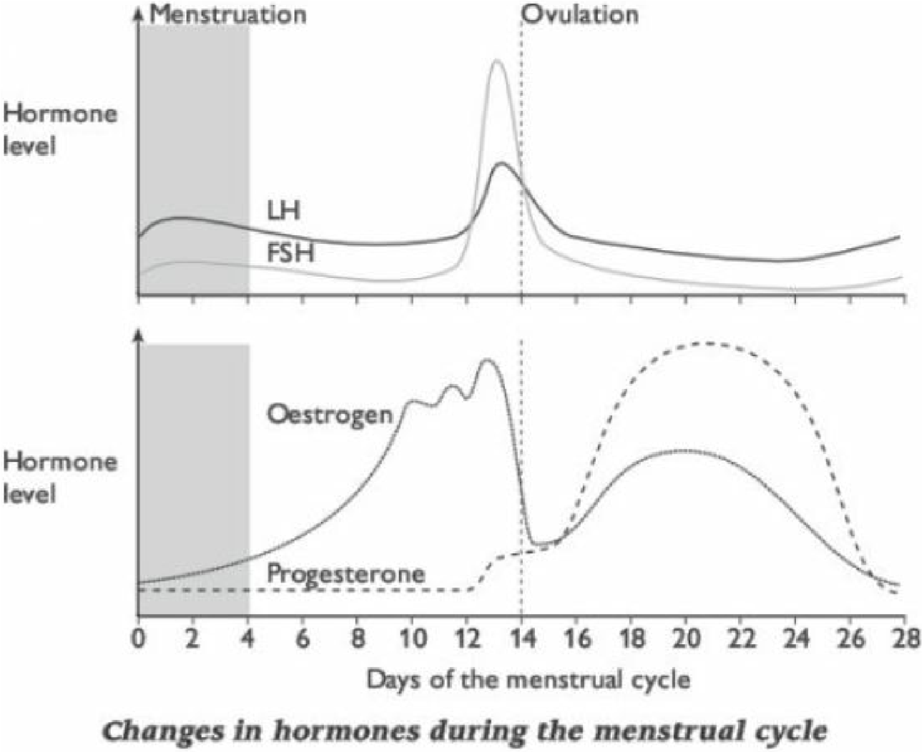

**Revision questions**

1. Describe the hormonal control of pregnancy in animals
2. (a) Explain the absence of York sac in development of human foetus while it’s an important structure in the development of birds and reptiles
   1. State reproductive adaptations of birds to terrestrial life
   2. Give forms of parental care provided by mammals
3. (a) Explain functions of the mammalian placenta as a barrier

## (b) Explain the series of events that take place after fertilization which leads to formation of placenta.

4. Describe the methods of fertilization and other reproductive strategies in mammals that have contributed to their evolutionally success.